Welcome To New Beginning Animal Sanctuary’s Corn Snake Care Guide

Introducing the Corn Snake
The corn snake is a “red rat snake” from the genus Pantheropis guttata (previously Elaphe). Corn snakes are an easily tamed snake that are bred in captivity in large numbers, widely available in a massive variety of colours and patterns, is relatively small – grows from 3 to 6 feet in length – and remains a slender and light weighted for easy handling.
The wide variety of colours available along with it’s ease of care and friendly personality make it a very popular pet – one of the most popular exotic pets in captivity, suitable for beginners and experienced keepers of all ages.
The corn snake has a lifespan that is usually described as 15-20 years, however the oldest corn snake recorded in captivity was over 32 years old and we’ve personally experienced many of our corn snakes living into the mid 20s with excellent care. It’s fairly safe to say your corn snake should be around for quite a while. This is true of almost all species of snake, so buying a snake is always a commitment you want to think carefully about.
This is my personal guide to corn snakes having kept and bred them now for over 15 years.

Corn snake housing
Corn Snake Housing
When it comes to housing you have several options. Many keepers like to keep their baby corn snakes in a smaller enclosure than adults. This has advantages and disadvantages. The main disadvantage is that you will have to upgrade your setup in 6 months to a years time. The main advantages are that the snake may feel more secure, and be more inclined to eat, in a smaller setup. Some people put a corn snake straight into their adult setup and find that it adjusts well, others may be a bit afraid of the space.
Starter Setup
Your typical starter setup is very basic, and consists of
- 20-50 litre tub, Large Flat Faunarium or small vivarium/terrarium.
- Heat mat, covering 1/3rd to 1/2th of the tub. This goes underneath the tub.
- Mat Stat – a thermostat will automatically control the temperature of the heat mat, ensuring that the optimum temperature is maintained for the comfort and digestion of the snake. This is a critical piece of equipment that you cannot do without. Note that a a Thermostat is not the same as a thermometer.
- Thermometer – this reads out the temperature of the tank.
- 2 Hides – one on the heat mat side, the other on the cool side.
- Water Bowl – big enough for the snake to soak in whilst shedding, on the cold side of the tank.
- Small plants, branches or accessories can liven up the tank and provide stimulation.
- Substrate – for a brand new acquisition or a very young snake then paper towel or newspaper can provide an easy to clean substrate that allows you to monitor their feeding and digestion easily. Once established, we’d recommend a substrate such as aspen that allows for natural burrowing behaviour.
This setup is primarily the same as above, except the actual tank will be different – much larger – and this allows for the addition of lighting, which despite being described as nocturnal, is still important for corn snakes. There will be more detail on this in the lighting section.
- 48 x 18 x 18″ is our recommended size for a single adult corn snake but a 48 x 24 x 24″ is ideal. A 36 x 18 x 18″ is a bare minimum and in most situations will require upgrading, so we would recommend going straight for a larger size wherever possible.
- A larger heat mat will be required but again, it only wants to cover 1/3rd to 1/2th of the tank.
- Wooden vivariums usually come with a light fitting. A low wattage light bulb can be used to increase daytime heat, and provide a basking spot. Corn snakes will come out on a sunny day in the wild, and bask on a hot rock in the sun. A light bulb helps create this natural hot spot.
- If using a light bulb, a light guard will be absolutely necessary. Snakes have problems feeling burns, and often will wrap themselves around a light source and can cause themselves serious injuries.
- Dimming thermostat can be purchased to dim lights when they get too hot.

Glass Tanks
If you can get a glass tank that is secure and has the same floor space as a 48 x 18 x 18″ enclosure then you can adapt it for use, bearing in mind you’ll need to provide adequate heating and lighting. However commercial terrariums such as Exo Terra don’t go up to these sizes, and in our experience fish tanks are not deep enough and do not have secure lids. We generally recommend a wooden vivarium.

Heating
A corn snakes tank should be 80-88 F on the hot side. The cool side will naturally be cooler than this, and should be at least 4-5 F difference. At night time, a temperature of 70- 75F can be maintained. There are several ways of reaching, and controlling this temperature, discussed below.
Heat Mats
A heat mat is a device that you place underneath the tank in the case of plastic or glass, or inside the tank, but underneath the substrate in the case of wooden vivariums. A heat mat should never cover more than 1/3rd to 1/2th of the tank, and come in a variety of different sizes and wattages. Typically a heat mat ranges from 5W to 30W and is an inexpensive appliance to run. Heat mats can be used all day and all night if necessary, and it is essential to use them on a mat stat thermostat to ensure overheating does not occur.
The downside of a heat mat is that they can be easily damaged by water, snakes have a tendency to get under them if possible and sit directly on them which is not ideal, and they are not suitable for heavier bodied snakes. Heat mats are not suitable for heating larger tanks as the wattage is too low.
Ceramic Bulb
Ceramic bulbs are a lightless bulb that have a high heat output, up to 250W or more. They should be used carefully, and always in conjunction with a guard. Always make sure that the fitting you are using is rated up to the wattage of the bulb. Ceramic bulbs can be left on 24/7 and can be controlled with a pulse thermostat for a very accurate heat output. This makes them the most efficient way of heating a tank, from small tanks up to very large tanks.
Light Bulbs as a Heat Source
Red light was often used in the past for a 24 hour heating cycle as it is said that snakes cannot see red light. However, as we know more information about snakes in general, we realize it’s possible snakes can see more light than we previously realized. There’s no real advantage over using a light bulb compared to a ceramic bulb, and the downside is they’re not available in high wattages, may blow more often, and a white light needs to be turned off at night, whilst a red light is still debatable.
We recommend not using light sources for heat, but purely for lighting, see the next section!
Controlling Temperature – Thermostats
A thermostat controls the temperature of the device it is attached to. These are simple devices that can help maintain the temperature at optimum, which helps with the overall health of the animal. Both extremes of hot and cold can be very damaging to reptiles, as they cannot regulate their own body temperature like mammals. A thermostat is an essential piece of equipment for the responsible owner. I have seen snakes with horrific burns from malfunctioning heating equipment and on the other end of the spectrum, a snake too cold will go off their food, or if food is left undigested in a cold body, can rot and the snake can die!
There is simply no excuse for using a heat device without a thermostat anymore.
Measuring Temperature – Thermometers
Even if you have a thermostat to control the temperature, it will be useful to know what the temperatures in your tank are. Temperatures range from the basic £2.99 dials, up to the £20+ digital readers. In the best case scenario you will know what the temperature is on the hot and cold end of your tank.

Lighting
We recommend having a low wattage LED bulb for a natural daytime light in your corn snake tank, along with a low level of UVB.
Whilst corn snakes are nocturnal, they are often described as crepuscular. Like most nocturnal reptile species, they can be seen at dawn and dusk. New studies are constantly improving reptile care, and we are using research from Arcadia Reptile which shows the benefits to health, including appetite, activity and colour when using UVB.
Read our full UVB guide for in depth information on UVB.
You can either use a UVB tube with controller, or an all in one UVB kit. It must be guarded because a corn snake will wrap itself around the tube, which can both damage the tube and burn the corn snake.
Substrate and Decor
If you are quarantining a snake or have a very young snake then we recommend something that makes the enclosure easy to sanitize and which you can feed on and clearly see the digestive process. In this situation, it’s paper towel or newspaper.
As a permanent, natural measure we recommend a dry aspen type substrate which will allow for burrowing.
Some keepers use orchid bark but this does increase the humidity and a corn snake in an enclosure with too high humidity can suffer from respiratory problems or scale rot. Another option that some people like are bark chips, but these are not as easy to burrow in as aspen and can be harder to change out.
You’ll need a minimum of two hides, one on the hot side and one on the cool side, but providing different types of hides at different levels in the vivarium will provide a more natural environment. Although these are a ground dwelling snake, they do enjoy climbing and will make use of branches, plants and shelving. The more interesting and natural decor you provide within the enclosure, the more active, interesting and natural behaviour you will see in return from your corn snake.
Corn Snakes in Bioactive Setups
Although a corn snake does not come from the desert, a corn snake bioactive setup needs to be what we call an arid setup. Corn snakes come from both forested areas and plains areas, but these are in North America, and not a hot and humid climate.
Arid bioactive setups are a bit more complicated than rainforest bioactive setups to keep running, as the plant selection can be harder to establish but are possible with a good size vivarium and plenty of research. We can help you and sell you the majority of the equipment you need, but drop us a message as we can cater the setup to your specific requirements. We hope to write a guide on this soon!

Housing Corn Snakes Togther
In the wild corn snakes do not live in groups other than when necessary for convenience, such as to find heat or food, and we’ve seen no evidence that a corn snake struggles when living alone. I often hear people say “my corn snakes are always cuddled up together” as a reason to keep them together, but the reason that corn snakes huddle together is because there is an optimal safe spot in a vivarium, such as a hide on the hot side. There is also safety in numbers and snakes may feel that one spot is the safest place to be. Therefore you will find them together because that is where they determined the best environment was – not because they wanted to cuddle their cage mate.
We recommend that corn snakes are kept one per enclosure where possible.
If you are keeping corn snakes together, you should never feed them in the same enclosure and you should only keep two females together. Two males will become agitated during breeding season and the dominant one may mate with the other. A male and female will breed and this can result in unwanted eggs in a female who is not ready. If you are specifically looking to breed then I would always place the male and female together for a brief period then separate so you can monitor individually.

Handling Your Corn Snake
Corn snakes are very easily to handle. They are a placid species that have been bred in captivity for many generations. They are not easily startled as adults, but hatchlings can be nervous because they are born small and vulnerable with an instinct of fight or flight. As your corn snake grows, they will soon learn that you’re no threat at all.
Do not handle your snake for 24 hours after eating as this stimulation can result in regurgitation.
I find new handlers can be worried about being bitten. Corn snakes do have small teeth, but these teeth are not used to kill the prey – a corn snake is a constrictor, and can do little damage to you. Hatchlings may not even be able to break the skin, but even an adult bite cannot puncture deep. A hamster bite is deeper and more painful.
We recommend always washing your hands before handling your snake, as they have an extremely acute sense of smell, far more accurate than their vision, and if they smell food, they might get confused and bite.
Handling should be done with confidence, but also with due care. Young hatchlings can be flighty and fast, and should be handled either in the vivarium, or whilst sitting down on the floor or on a bed, to ensure you can easily catch them again.
Try not to hold your snake tight, they don’t like being grabbed, as this is what a predator would do when catching them. Let them roam freely on your hands, arms or through your fingers, without putting pressure on them.
If you need to pick them up, a firm grip along the midsection will do it, and support their bodyweight with your hands. Do not pick them up and hold them by the tail alone, this is fragile, and can be broken. It is best to avoid touching the head areas, as almost all snakes are irritated by having their head touched, and the same goes for the tip of the tail.
Wash your hands again after handling, before eating food as all reptiles can carry trace amounts of salmonella that can give you a bad tummy.

Feeding
Corn snakes can be fed from 5-7 days as hatchlings.
As they grow they will use less of their food energy in growth. Once they are at their full size, usually at 3 years+ you can slow down to feeding every 7-10 days.
You should feed one prey item that is no more than 1.5 x the maximum width of the body. The jaw will dislocate to allow the food to be consumed; the neck will look very stretched whilst eating, but return to normal as soon as the food as moved down the body. Eventually it should create a small bulge in the snakes stomach.
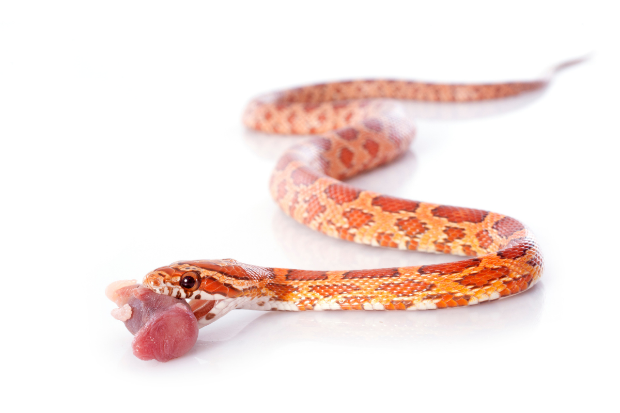
If your snake has a small head or prefers smaller prey items, it is possible to feed two small items.
Don’t be tempted to overfeed or powerfeed your snake; snakes that are fed too much and grow too quickly can suffer long-term health problems including heart and kidney problems.
As a hatchling your snake will eat pinky mice. As it grows it will move up in size to fuzzy mice (these have hair and are usually around 10-14 days old), to crawler or small mice (young mice with open eyes, out of the nest), to medium, large and potentially even XL mice. Very large corn snakes may even take a rat weaner.
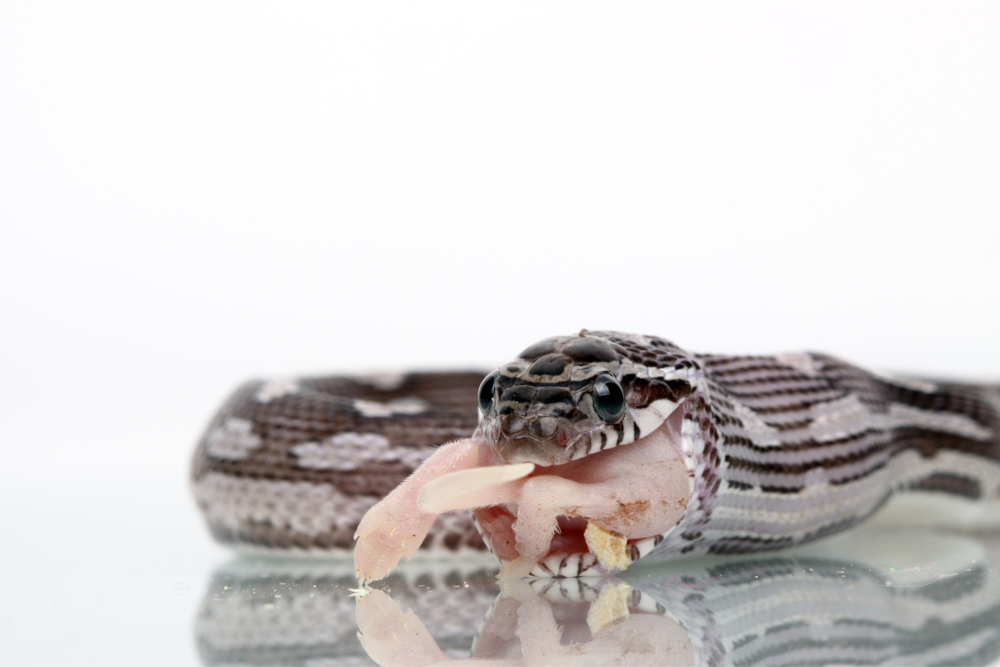
Feeding corn snakes is usually a simple affair, most are good eaters. If your snake goes off his/her food for one or two weeks it is nothing to be seriously concerned about. If you find that your snake is not eating for longer than this, you need to double check your habitat and temperatures and give your corn snake a thorough health check.
Some corn snakes will strike feed, others will eat overnight. If your find your corn snake is food-aggressive you may benefit from removing them from their vivarium and placing them in a tub to feed to avoid the association of food in their vivarium, but for most this is not necessary. If your corn snake is a strike feeder you may wish to use a pair of tongs to avoid any accidents!

Breeding
Before breeding any snake you should think about it very carefully. Please consider:
Health of Parents – The parents must be healthy with no genetic defects that can be passed on. We used to go by the rule of three. The female should be three years old, 3 foot long and 300g in weight as a minimum. Personally I like them to be a bit bigger than that, 350g where possible. The length is not particularly important. Some people will breed snakes too much resulting in a large, younger snake – a snake bred too young may be permanently growth stunted and more likely to suffer from egg binding or other post-breeding issues.
Veterinary Treatment – You must be prepared to provide veterinary treatment for the parents of the offspring if needed. Females can become egg bound and require treamtent, whilst it’s always possible that hatchlings will need medical attention. This can become costly, so make sure you’re prepared.
Incubation – You will need an incubator set up in advance.
Feeding and Housing the Hatchlings – Each hatchling will need to be housed in an individual container and you will need to make sure your temperatures are correct. You will need to provide at least 5-6 feeds before you sell these on to new homes.
Finding New Homes – A single corn snake can lay 20-40 eggs in a year. You need to make sure you’re prepared and capable of finding homes for this amount of snakes. You should be aware that shops and wholesalers are not likely to pay anywhere near the prices you see snakes advertised at.
Brumation
For best success males and females should be brumated / cooled over the winter period. Temperature and photoperiod are an important trigger for breeding. Although corn snakes can breed without, simulating the natural environment is a way to increase your success rate.
First, ensure the digestive system is fully emptied by giving 2-3 weeks after the last feed at normal temperatures, then I cool my corn snakes around 10-15C for approximately 8-10 weeks. I do this by moving them to a cold unheated room in 50L tubs on a heat mat and thermostat. These are temporary tubs and not what the corn snakes live in full time as they are too small, designed to limit activity during brumation. Depending on your rooms, this may need to be a garage, loft or shed. Wherever you decide, set it all up in advance and test your temperatures fully before adding your snakes. Make sure that you’ve paid good attention to fire and safety, with a smoke alarm installed if not keeping inside your living areas. Some people will need to heat a very cold area with an external heater such as a radiator.
Water should be available during brumation and you should make regular checks every week or two to ensure they’re in good health. After your 8-12 weeks, bring back to normal temperature and give at least 7-10 days before feeding.
Breeding
With spring here, your corn snakes should have been brought up to normal temperatures and you should have them back in their full size enclosures. If you have lighting in the enclosure (which is highly recommended), you can now increase this to simulate longer days. This will kickstart the corn snakes reproductive system. They will usually shed their skin as soon as the temperature is increased and this is a great indication that they are getting ready to breed.
Snakes can be introduced for a brief period and then separated, or left together. I prefer to introduce, watch copulation and then separate. This gives me exact dates so I know when to expect eggs. Misting the enclosure directly before introduction can help increase the males detection of the female hormones.
The male will position himself on top of the female and a receptive female will lift her tail, enabling copulation. They may copulate for as little as a few minutes, or as long as a few hours!
The female will shed approximately 4-6 weeks after mating and will lay their eggs 1-2 weeks after this pre-natal shed.
You will need to provide a large, damp moss box. We use large tupperware tubs with a hole cut in the lid (make sure it is smooth and not sharp), with eco earth in the bottom and fresh moss on top of the earth. There are usually between 10 and 30 eggs, although first clutches can be very small.
Once she has finished you need to remove the eggs to the incubator.
Incubation
The safe temperature for incubration is 79F to 89F (26C – 31C), but I recommend the lower end of this scale. Corn snakes incubated at higher than 90F can have birth deformities, so low 80s gives a little bit of leeway for temperature fluctuation.
Eggs will hatch between 60 to 75 days. The snake will cut a slit in the egg with it’s special egg tooth, which then falls off. They may sit in the egg with their head out for up to two days after slitting the egg whilst they absorb the rest of the nutrients. Unless you think the snake is in distress, you should leave them alone whilst they hatch. Unfortunately some do slit the egg and then perish, and some never slit the egg at all. But the majority of your snakes will hopefully make their way out successfully.
Hatchlings need to be housed separately in secure tubs. They will shed after 7-10 days and will then start to eat defrost pinky mice every 5 days or so.
Morphs
There are now a massive array – literally hundreds – of different combinations of corn snake morphs. The morph of the corn snake refers to the genetics that make up the colour and pattern. It’s worth noting that hatchling corn snakes often look very different to adults, so when deciding on a colour it’s always worth searching for images of adults rather going off what the hatchling currently looks like.
With the exception of scaleless corn snakes, the care for all morphs of corn snake is the same and when purchasing a pet corn snake, it’s purely about aesthetics and which one you like the look of! If you’re picking corn snakes for future breeding projects, then the morph becomes important and you need to look at the genetics of the morphs you have and what they would create.
Here are some of the more popular corn snake morphs, but this list is not exhaustive:
Normal (Wild, Okeetee, Carolina, Miami, Alabama) – This is the normal morph that you would find in the wild. There are several different localities which look slightly different but are genetically still a normal corn snake. It is red and brown with black chequered belly scales and a brown eye.
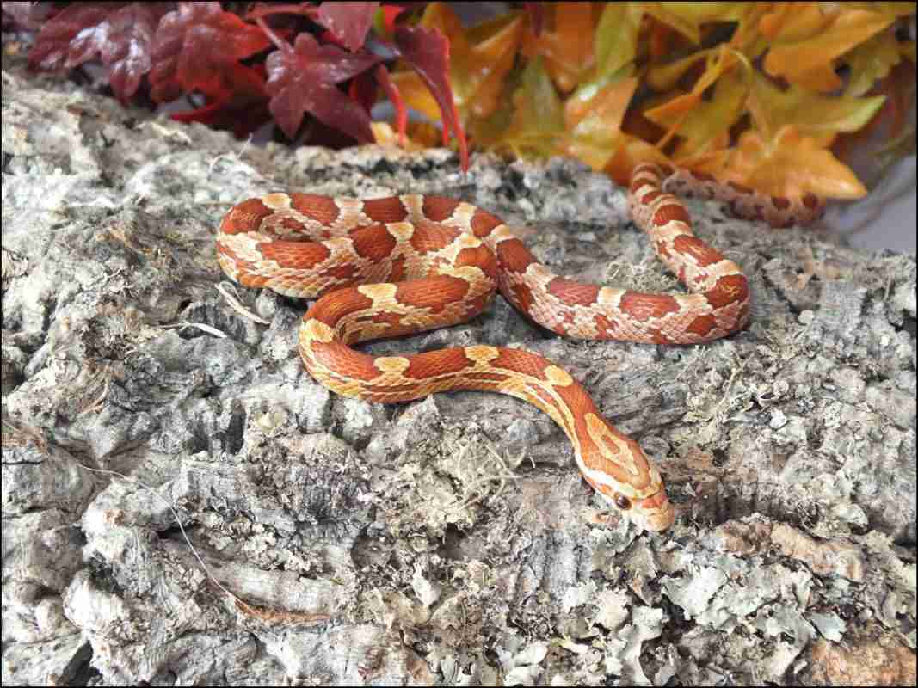Normal Corn Snake, Reptile Cymru
Single gene colour morph genetic traits
Amelanistic (Amel / Albino) – This is the albino form and is orange and red with yellow chequered belly scales.
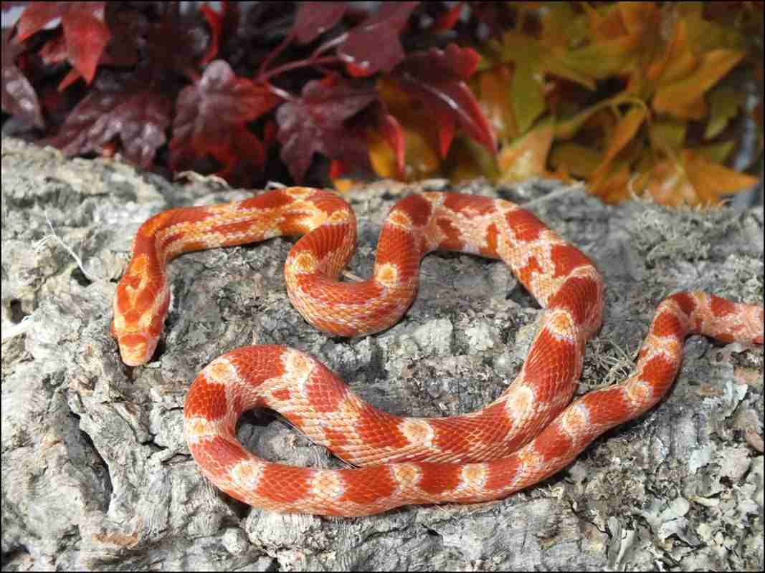Amel Corn Snake, Reptile Cymru
Anerythistic (Anery) – Black and grey / silver coloured scales, with varying degrees of yellow around the sides of the head / neck. Grey / silver eyes and black / white chequered belly scales.
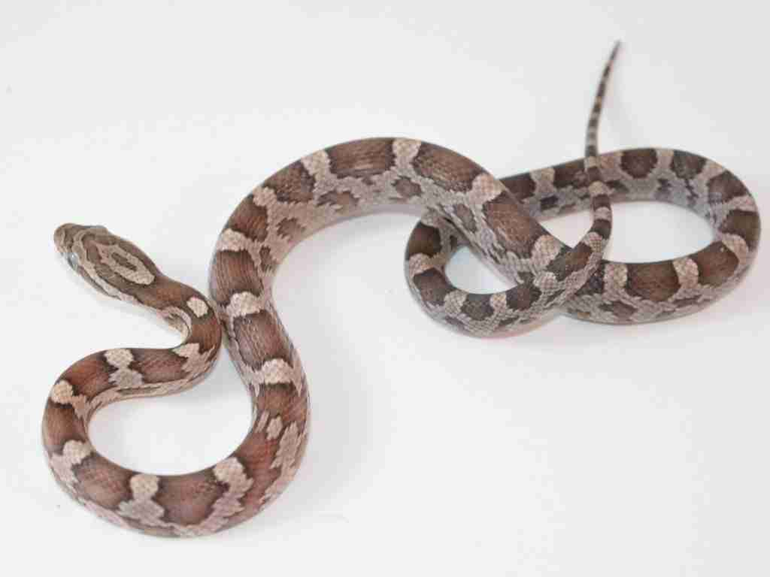Anery Corn Snake, Reptile Cymru
Caramel – Pale brown / golden caramel colour scales, varying amounts of yellow, with a caramel / light brown coloured eye and black / white chequered belly scales.
Charcoal (Anery B) – Black and grey / silver coloured scales, usually darker with a more faded look to standard Anery. No yellow. Silver / grey eye and dark grey or black / white chequered belly scales.
Cinder (Anery C) – Black and grey / silver coloured scales with a washed out, faded appearance. Often low contrast between the two colours. Silver / dark grey / black eye, with a black or grey / white laddered belly as opposed to chequered.
Diffused – Diffused refers to a loss / blurring of the side patterns, an increase in colour pigmentation and a belly that is absent markings. This was previously called bloodred, but the genetics of diffused / bloodred are quite complicated with multiple components that are not well understood! It’s worth noting that heterozygous animals can also lack belly scales, so a blank belly is not guarantee of an animal being visual diffused.
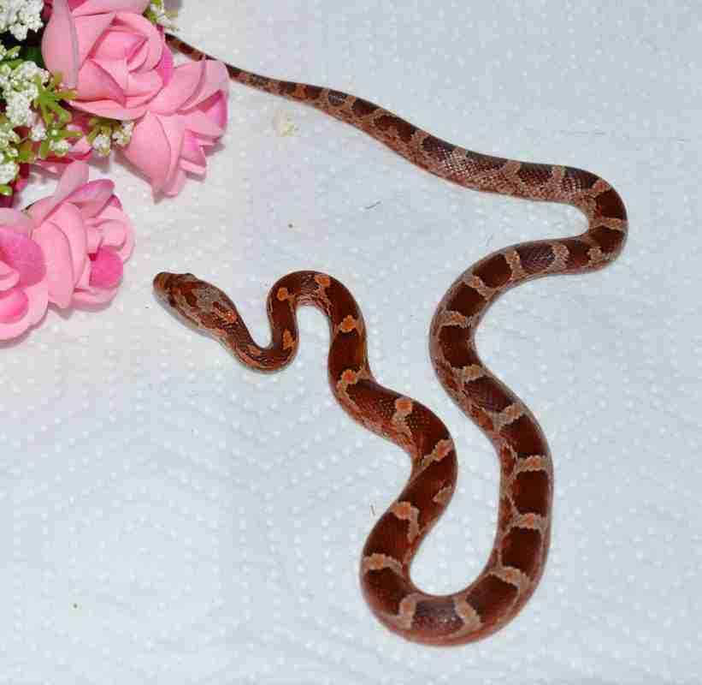Diffused Corn Snake, Reptile Cymru
Hypomelanistic – Similar to a wild type in colouration but lacking black pigmentation for brighter red / brown scales. Brown eye, and these usually have a faded black / brown / white chequered belly.
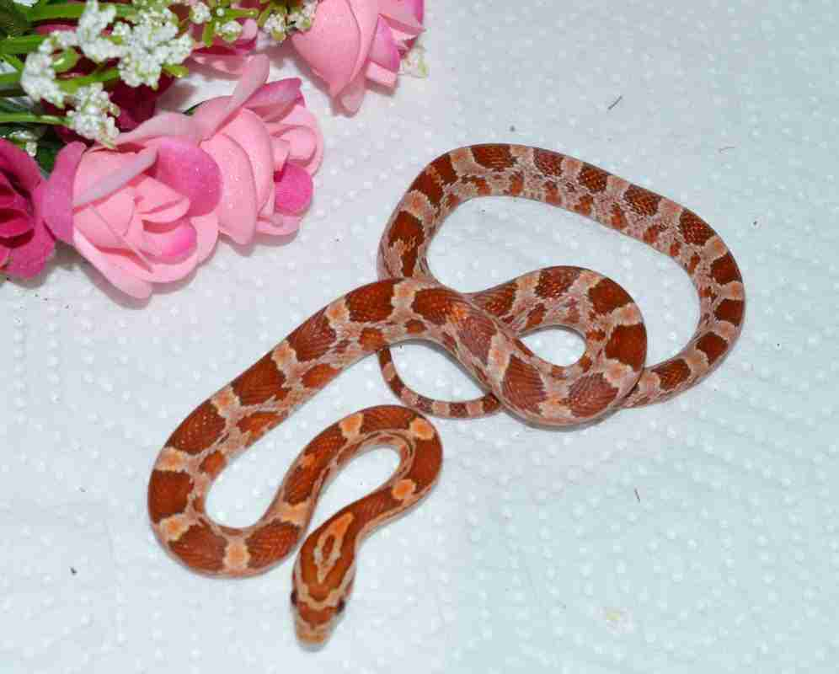Hypo Corn Snake, Reptile Cymru
Lava – Lava is very similar to hypomelanistic but a more extreme version and a seperate recessive trait, resulting in a snake lacking black pigmentation. This black pigmentation as an adult often shows up dark purple. Brown eye and a faded black / brown / white chequered belly.
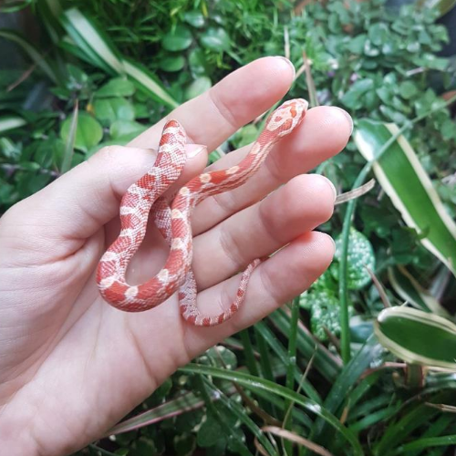Lava Corn Snake, Reptile Cymru
Lavender – A very light grey / silver snake with purple overtones. Light grey / dark grey / purple coloured eye, very pale grey / purple laddered belly scales. Note that hatchlings look very different to adults and this morph can take several years to show true to form.
Sunkissed – Sunkissed is a variant of Hypomelanstic, resulting in reduced black pigmentation and a brighter coloured snake. Sunkissed often have a more rounded saddle pattern with side blotches, a brown eye and a faded black/brown and white belly chequer pattern. It was previously called Hypoemelanstic Type C.
Double and Triple Recessive Traits
Each of these single traits can be combined with one, two, three or even more other traits. Sometimes this creates something completely different. There are currently hundreds of different combinations. Rather than list them all here, I’d like to refer you to Ian’s Vivarium Corn Morph Project which lists all possible combinations, along with user submitted photos so you can get an idea of what these combinations look like.
Every year even more combinations, and sometimes completely new traits are still discovered!
Scale pattern genetic traits
Motley (Recessive) and Stripe – Lacks black pigmentation and has circular or square back markings, with sides that are usually striped or dashed. Stripes can have complete or partial stripes. Completely unmarked belly. Motley and stripe share the same allele, stripe is dominant to motley but the gene is often referred to as Motley Stripe.
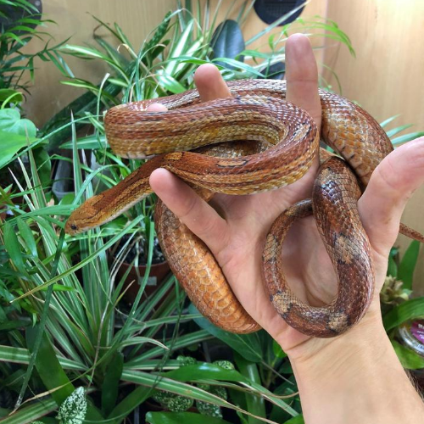Normal Motley Corn Snake
Palmetto – The first ever palmetto was discovered in the wild in just 2008, so this is one of the newest wild occuring genes on the market. The Palmetto lacks the usual corn snake patterning and instead is white with coloured speckles, often with distinctive head scales and completely unmarked bellies. In the absence of DNA testing there is no way of knowing if the original single male from which all captive bred palmettos are bred from was a pure corn snake or a hybrid but if you’re interested in the history and in depth description of this morph, I recommend reading this article on The Story of the Palmetto Corn Snake.
Tessera (Co dominant) – The Tessera pattern has a thing, striking mid dorsal stripe, sometimes broken up into dashes, sometimes entire. The side is a square pattern.
Terrazzo (Recessive) – Terrazzo are an unusual looking corn snake that was created from breeding two rosy rat snakes (also known as Keys corns) together. They have a jagged striped pattern with side dashes / stripes and a blank belly that often retains colour from the morph. Due to Keys corns being a smaller variant of rat snake, Terrazzo corns are often smaller and leaner than typical type corn snakes.
Corn Snake Hybrids
Corn snakes are sometimes bred between sub species or even species to create new morphs. In some situations this can change the snake drastically, for example, jungle corn snakes which are a corn and king snake hybrid can retain the cannibalistic traits of the king snake, meaning none can be kept in containers together safely. It’s important to know if you’re buying a pure corn or a hybrid corn snake just for your own health records and to make sure you’re keeping them in the best conditions possible.

